**Advance Algorithm for Fire Detection Using Image Processing and Color Recognition**

Patil A.D.1*,*Kuwar K.R.2, More M.S.3,Pagar P.A.4&Somawanshi S.D.5

*1,2,3,4,5(Comp.Engg.Dept.,LGNS COE Nasik,SPP Univ.Pune(MS),India)*

***Abstract :*** *In today’s world we find it is mandatory to have a fire extinguisher in every building according to the norms of government. But when there is fire breakout there is chaos and confusion of either vacating the area or turning on the fire extinguisher and extinguishing the fire, for that proper training must be required and given to the employees or personal residing in the building in order to turn on the extinguisher. So we have overcome this problem, which would detect the fire automatically and directly turn on the extinguisher on its own.By using different image processing techniques fire can be detected effectively. In this technique, images like photographs or frames are the inputs and output may be either an image characteristics or image. By using image processing various tasks like image segmentation, smoothing, recognizing multiple and different patterns can be performed. Image processing greatly help to detect fire in a good manner also avoid dangerous situation according to the output. This paper describes different methods used for fire detection.*

***Keywords -****Fire detection, image processing, and rule based color model, image segmentation, imagesmoothing.*

# **INTRODUCTION**

Fire detection is very crucial for the safety of the humans. By using different image processing techniques fire detection can be possible. Smoke is the good identifier of fire. By analyzing the features and other characteristics at present in an image, detection of fire is done. [1] The paper specifies different fire detection techniques. (1) The required equipment used in this technique has less cost. Currently now a day’s closed circuit television systems (CCTV) are already installed in many public places for survey purposes. (2) The feedback time is faster as the camera does not need to wait for the smoke or heat to dispose. (3) The CCTV system can recognize a large area to create a higher possibility of fire identification faster as possible. (4) Analysis of direction of fire is done directly, only the radiant’s does not comes from its general vicinity. [2] As fire accident makes great disposes to our life and regions, fire flame detection is an important issue of modern security sensing system.

In image processing image is taken as input and the output may either an image or parameters of an image. Various tasks like extracting its features, detect various or different patterns are performed with the image processing. Using technique like image processing the features of fire can be extracted. By using techniques the accidental situations caused due to fire can be avoided. This paper specifics various fire detection techniques and their comparison. [1]

In this system we would be placing camera at various location in the surroundings like malls, campus. Using camera we would be detecting the fire using image processing. The input from camera is in terms of frames. So the camera is not an intelligent. So we are come up with an intelligent system which would be detecting fire. For doing this, first we need to train the system to recognize or identify the fire. By using advance color recognition algorithm we would be training the system to detection of fire. Once the system has learned to identify fire it can easily detect the fire on its own and turn on the extinguisher on its own. Moreover in our system we would be also training the system in a way to identify the direction in which the fire raised. It will make help to turning on the extinguisher on its own in specific direction. The system will also identify the intensity & volume of fire break and accordingly would sent alert to the fire brigade whom will get an alert from system.

This paper specifies about color edge identification algorithm. Detection of edge is one of the operations which are used most commonly used in image processing and pattern recognitions. An edge is the boundary in between an object and its background and defines the boundary within all objects. So the edges present in fire image can be identify efficiently and effectively, the various objects can be located and its basic features as shape, area and perimeter are recognized and measured. As computer aims to include the identification and classifying of objects in fire image, edge detection is required and essential tool. Accurate and Efficiency in edge detection will lead to increase the performance of subsequent image processing techniques, does image segmentation, object­-based image coding, and image extraction. Maximum color difference value is used to predict the value for thinning and for image which is colored technique is applied to extract appropriate edges is the threshold value. Edge detection in image which is color is far more challenging task than gray scale images as color space is considered as a space of vector. Almost 90% of edge specification in a color image can be found in the gray scale image as per correspondence. Thus, 10% can still be vital in certain computer vision tasks. First, the cost of technology is low and mostly systems are based on CCD cameras, which are found being already installed in many public places for surveillance purposes. Second, the response how fire and smoke detection is faster, as the camera does not require predicting for the diffusion of heat. Third, thus the camera also work as a volume sensor, as distinct from all other traditional sensors, it may check a specific area, defining a high probability of fire detect in an early stage. [3]

# **LITERATURE SURVEY**

Soumya Dutta, Bidyut b. Chaudhuri [3] proposed method is tested on different images. It produced stable and good results. In which acceptable outputs over different kinds of real life images have proved robustness of presented schema. Thus, for any computer vision task where extraction of edge maps is required for a large set of images for feature extraction or for any other work, this type of method may be suitable. Sheik Rasool, Dr.P.Pandarinath [4] proposed vision-based fire detection approaches offer several advantages, including relatively inexpensive equipment, a rapid response time, and fast confirmation through the surveillance monitor. Yet, fire detection approaches using a camera face certain challenges, as well as offering opportunities for the development of effective fire alarming systems. Most previous vision-based methods depend on color information and temporal variations in the pixels using empirical parameters. However these methods are often difficult to apply in practice, due to several factors, such as varying environmental conditions and fire materials. Thus, to overcome these limitations, this paper presented a fire detection algorithm using an adaptive background subtraction model. In general the patterns of fire and fire-like moving objects were analyzed and probability models of fire designed using several fire feature patterns. Because of this, the use of probability models and a Bayesian inference improved the detection performance and reduced the missing rate. We have analyzed the static and dynamic features of fire flame and proposed a flame detection algorithm based on the integration of patio-temporal information in the video [5]. Experimental results show that our flame detection algorithm can locate the position of flame accurately and can be applied to complex environment. The proposed technique can be incorporated with a fully automatic surveillance system monitoring open spaces of interest for early fire warning system. Y. Habiboglu, O. Gunay, and a. cetin [6] proposed another method that uses covariance descriptors for fire detection. In this method, color, spatial and domain information are combined by using covariance descriptors for each patio-temporal block. The blocks are generated by dividing the flame colored region into 3d regions. This method used a covariance matrix for the detection of flames. Background subtraction method is not used in this approach. To detect fire, divides the video into patio temporal blocks and covariance features are computed from these blocks. Using a svm classifier, the flame colored region are classified by using the spatial and temporal characteristics. These classified flame colored regions are tested using video data that contain flames and flame colored objects. For the classification of pixel colors chromatic color model. [8] Is used and analyzed fire colored pixels? Object detection and texture classification. Pietro morerio, lucio marcenaro, Carlo s.regazzoni, gianluca Gera [7] proposed another method that uses color features and motion analysis to detect fire and smoke. Smoke is a good indicator of fire and can easily determine the presence of fire. In this method classify the pixel as fire, smoke or background pixel and then clustered the pixels. Then analyze the internal motion of region to identify whether they are dangerous. In this approach a fire and smoke detection system is proposed and contains five modules: change detection, fire features extraction, smoke features extraction and chaotic motion detection. In change and motion detection module background subtraction is used to identify pixels which behave differently from the normal behavior of the background image. In color spaces and features extraction module performs a separation between fire pixel and smoke pixels from other pixels. In the case of smoke, separation is performed by swapping to l*a*b space [9]. Separation of fire pixels is accomplished by moving to ycbcr. Then pixels separated by change detection and feature extraction are joined together to get connected regions in region growing module. After that chaotic motion analysis is performed. After this analysis data fusion is conducted in which a pre-alarm is generated. Main purpose of data fusion is to filter false alarms. Data fusion task is accomplished by classifying the pre-alarm rectangles using a multi-layered perceptron (mlp).

# **PROPOSED SYSTEM**

To develop a robust fire detection system, we need to understand the nature of fire. When the fire temperature is low range changes from red to yellow and when the fire temperature is high range changes to white. The shape of the flame also changes rapidly. Thus, the fire region exhibits a structure of nested rings of colors changing from white at the core to yellow, orange and red. [2] Depend on this knowledge; the proposed color edge detection algorithm is composed of the following four components:

At first, the image is smoothed by median filter to suppress unwanted noise in image. Secondly, maximum directional differences of sum of gray values i.e. Red+ Green+ Blue are calculated. In the third step, image is threshold and finally the detected edges are thinned to get the proper edge map. Lastly, after the edge is mapped fire is detected and extinguisher gets turn on automatically and it send alert to fire brigade.

1. Smoothing by Adaptive Median filter

A traditional median filteris based upon moving a window over an image and computing the output pixel as the median of the gray values within the input window. If window is J x K in size then we can order the J*K pixels from smallest to largest in the gray level values. If J*K is odd then the median will be:

(J*K+1)/2........ (1)

And this entry in the list of ordered gray values. Note that the value selected will be exactly equal to one of the existing gray values so that no round off error will be involved if we want to work exclusively with integer gray values. For random types of noise, they provide excellent noise reduction capabilities and which helps to preserve edges because of this median filters are popular. In this method we have used an adaptive median filter. One main reason for using adaptive median filter is that it seeks to preserve detail of the image while smoothing the non impulse noise, something that the “traditional” median filter does not do [3].

The working of an adaptive median filter is divided into two levels and as follows:

Level A. A1 = Zmed - Zmin

A2 = Zmed - Zmax

If A1 > 0 AND A2 < 0, Go to Level B

Else increase the window size

If Sxy < Smax repeat Level A

Else output Zxy

Level B.B1 = Zxy - Zmin

B2 = Zxy - Zmax

If B1 > 0 AND B2 < 0, output Zxy

Else output Zmed

Where Zxy= gray value at coordinate (x, y), Zmax= max gray value, Zmin = min gray value, Sxy = window size, Smax= max allowed window size. Maximum allowed window size for our experiment was 9X9 starting from 3X3 window.

1. Directional Color Difference Calculation

In the proposed method, color image is analyzed from RGB colorspace**.** In each color pixel there are three color channels known as RGB component. The range lies between 0 - 255. Edges exist in a color image where changes of RGB values occur. So for detecting proper edges, firstly color differences in an image must be pointed-out in four directions and they are 0o, 45o, 90o and 135o. For reducing the computational overheadwe have calculated a transformed value for each pixel which converts three component valued pixels into a single attribute. This type of transformation is simply a weighted addition of three components.

Pixel(i,j)=2*red(i,j)+3*green(i,j)+4*blue(i,j)........(2)



Fig 1.Check box color image

For images like figure 1, check box we can see that the image consists of three fundamental colors. So if we compute the sum of three channels for each pixel it will be 255. Because, for the red regions, the value of the red component is 255 and values of green and blue components are 0. Similarly, for blue regions value is 255 and for red, green pixels will be 0. Same problem will arise for green regions. Using the weighted sum techniquewe can calculate exact color differences.



Fig 2. (a) A [3] [3], (b) B [3] [3], (c) C [3] [3], (d) D [3] [3] Four 3X3 directional masks are applied to the image smoothed withadaptive median filter



Fig 3. 3X3 Mask with coordinates

All four masks shown in figure 2 are moved over the transformed pixel values one by one to calculate the color differences in four directions. Mask A calculates horizontal color differences; mask B calculates vertical differences, mask C in 45o direction and mask D in 135o direction considering f (i+1, j+1) as the center pixel.

1. Threshold Technique

Threshold technique is very important task in edge detection algorithms. The accuracy of an algorithm is dependent on threshold parameters. A foremost criterion of thresholding is that the program should be efficient enough to automatically compute the optimum threshold parameter. Criteria of selection of a parameter as given below [3]:

1. It should contain most of the prominent edges;

2. It should not contain too much spurious edges;

3. It should be meaningful and visibly pleasing;

The proposed scheme suggests a method of parameter selection that works on various images. So that we calculate the maximum color difference using (˜f (i+1, j+1) | max) for each pixel. Average value of the maximum color difference is computed:

row col

t = (˜f|avg) =™ ™ [˜f (i, j) / (row*col)] i=0 j=0............ (3)

The proposed method uses single threshold value T. For that several ways to obtain a fixed value of parameter. The simple way to observe the edge maps for a set of selected images and take that value which is producing acceptable edge maps for all the selected images .The various kinds of images it produced edge maps which is acceptable at 1.2t.Then Threshold value (T)=1.2t.

1. Edge thinning

Edge map produced in this way contains thick edges. So a thinning technique is applied to create more thin edges which will be more accurate and visibly soothing.

.

(a) (b) (c)

Fig 4. (a) Fire image, (b) multi pixel thick edge map after threshold,

(c) Final edge map after using thinning masks.

1. An Action performed by an Extinguisher and Alert system

In this system has learned to identify fire it can easily detect the fire on its own and turn on the extinguisher. Moreover in this, we would be also training the system in such a way that can identify the direction in which there is fire break out. This would help in turning on the extinguisher in that particular direction. Also the system would check the intensity & volume of fire break and accordingly would sent alert to the fire brigade which currently has to be done manually.

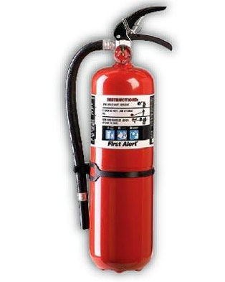

1. (b)

Fig 5. (a)Alert image, (b) Extinguisher

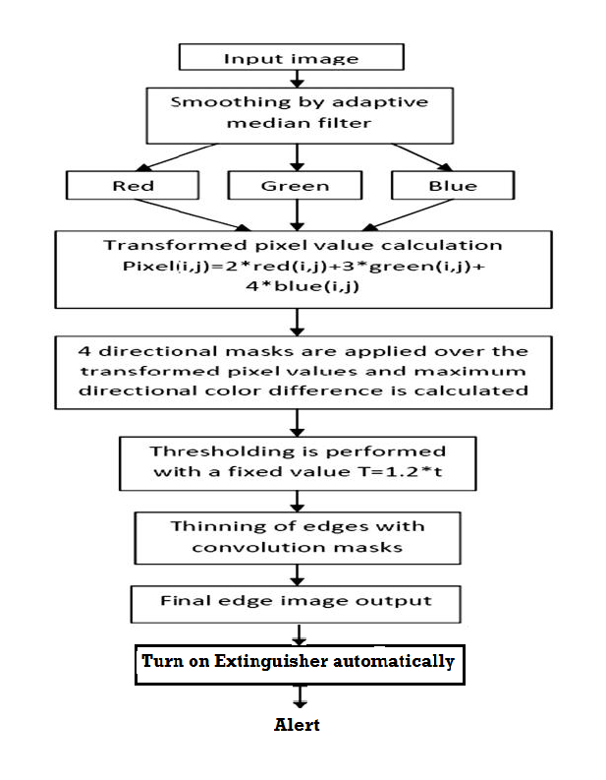

Figure 6.Steps of proposed method

# **CONCLUSION**

In this paper, we have analyzed the static and dynamic features of fire flame and proposed a detection algorithm based on the integration of spatio-temporal information in the image. It shows that detection algorithm can locate the position of flame accurately and can be applied to complex environment. Vision-based fire detection approaches offer several advantages, including relatively inexpensive equipment, a rapid response time, and fast confirmation through the surveillance monitor. Yet, fire detection approaches using a camera face certain challenges, as well as offering opportunities for the development of effective fire alarming systems. Most previous vision-based methods depend on color information and temporal variations in the pixels using empirical parameters. Thus, to overcome these limitations, a fire detection algorithm using an adaptive background subtraction model is introduces.

# **REFERENCES**

1. Surya.T.S, Suchithra.M.S*,Survey on Different Smoke Detection Techniques Using ImageProcessing, IJRCCT-2014.*
2. Shaik Rasool, Dr.P.Pandarinath, M.Tech, Ph.D,*an Auto adaptive Edge-Detection Algorithm for Flame and Fire Image Processing, International Journal of Computer & Organization Trends –Volume 3 Issue 11 – Dec 2013, ISSN: 2249-2593.*
3. CELIK Turgay*, Fast and efficient method for fire detection using image processing,ETRI journal, vol. 32, no. 6, pp. 881– 890, 2010.*
4. Liang-Hua Chen and Wei-Cheng Huang*, Fire Detection Using Spatial-temporal Analysis,Vol III, WCE 2013, July 3 - 5, 2013, London, U.K.*
5. Liang-Hua Chen , Wei-Cheng Huang*, Fire Detection Using Spatial-temporal Analysis , Proceedings of the World Congress on Engineering 2013 Vol III,WCE 2013, July 3 - 5, 2013, London, U.K. ISBN: 978-988-19252-9-9,ISSN: 2078-0958 (Print); ISSN: 2078-0966.*
6. Soumya Dutta, Bidyut B. Chaudhuri,*a Color Edge Detection Algorithm in RGB Color Space, IEEE TRANSACTIONS, VOL. 8, NO. 5, MAY 2013, 978-0-7695-3845-7/09 $26.00 © 2013 IEEE, pp-339.*
7. Y. Habiboglu, O. Gunay, and A. Cetin*, Flame detection method in video using covariance descriptors,IEEE International Conference on Speech and Signal Processing, pp. 1817-1820, 2011.*
8. Pietro Morerio, Lucio Marcenaro, Carlo S.regazzoni, Gianluca Gera*, Early fire and smoke detection based on colour features and motion Analysis, 978-1-4673-2533-2/12/$26.00 ©2012 IEEE.*
9. Thou-Ho Chen, Ping-HsuehWu, and Yung- Chuen Chiou*, An early fire-detection method based on image processing, in ICIP ’04, 24-27 2004, vol.3, pp. 1707 – 1710 Vol. 3.*